**Name = Nihar**

**Sap ID = 500091867**

**Roll No = R2142210525**

**Experiment No -3**

**Title** - **Introduction to Python with supporting libraries**

* Data formats read by python
* Reading free-field text data files
* Reading statistics data files
* Reading Excel files
* Viewing the data

import pandas as pd

#code:-

#reading of csv file

df=pd.read_csv("Iris.csv")

print(df.head())

Output:-

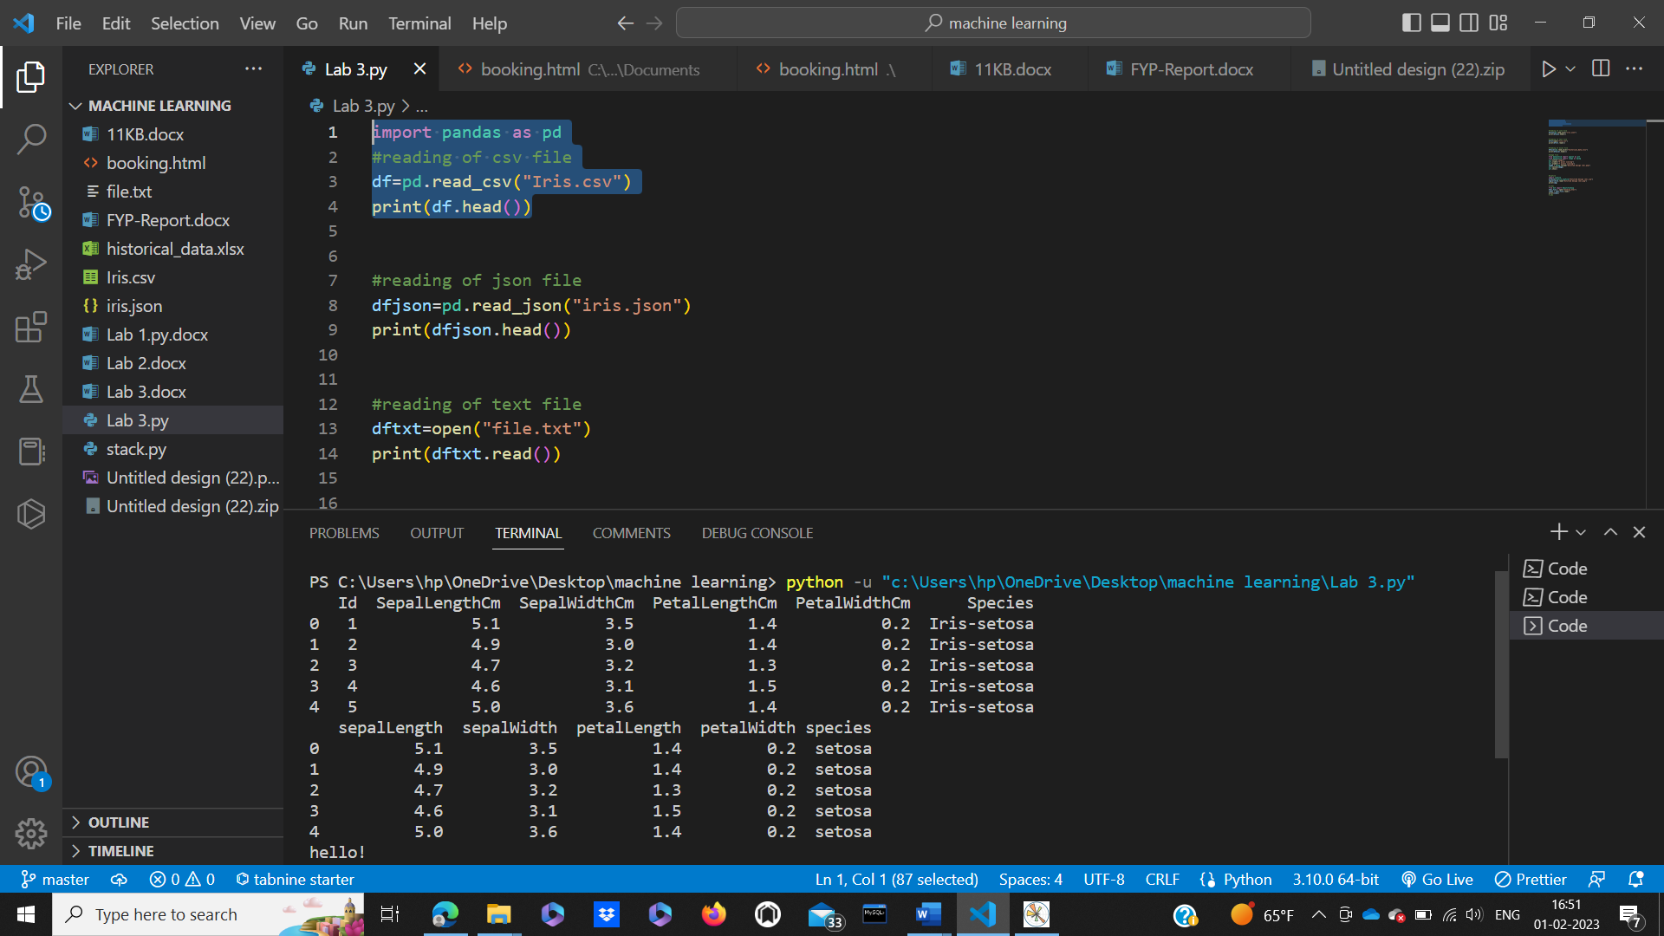

Code:-

#reading of json file

dfjson=pd.read_json("iris.json")

print(dfjson.head())

Output:-



Code:-

#reading of text file

dftxt=open("file.txt")

print(dftxt.read())

Output:-

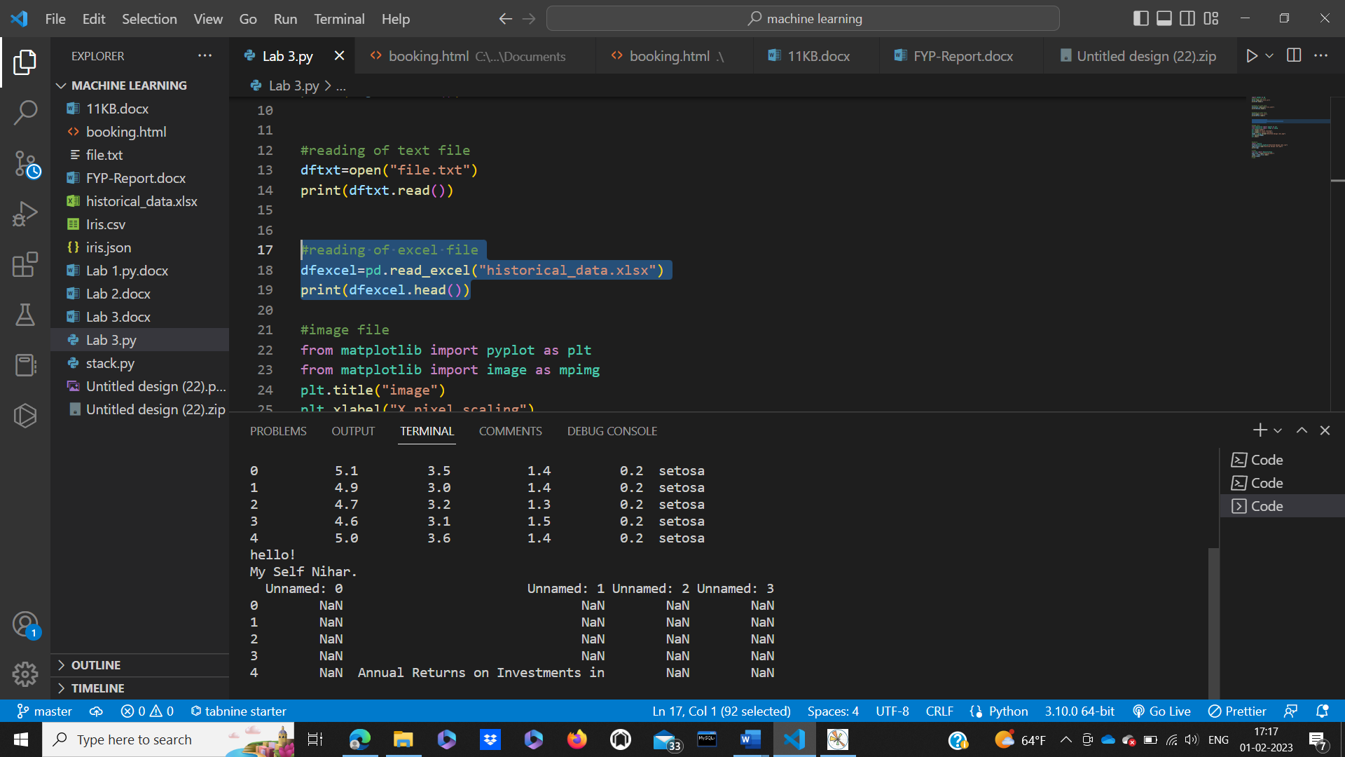

Code:-

#reading of excel file

dfexcel=pd.read_excel("historical_data.xlsx")

print(dfexcel.head())

Output:-



Code:-

#image file

from matplotlib import pyplot as plt

from matplotlib import image as mpimg

plt.title("image")

plt.xlabel("X pixel scaling")

plt.ylabel("Y pixels scaling")

image = mpimg.imread("Untitled design (22).png")

plt.imshow(image)

plt.show()

Output:-

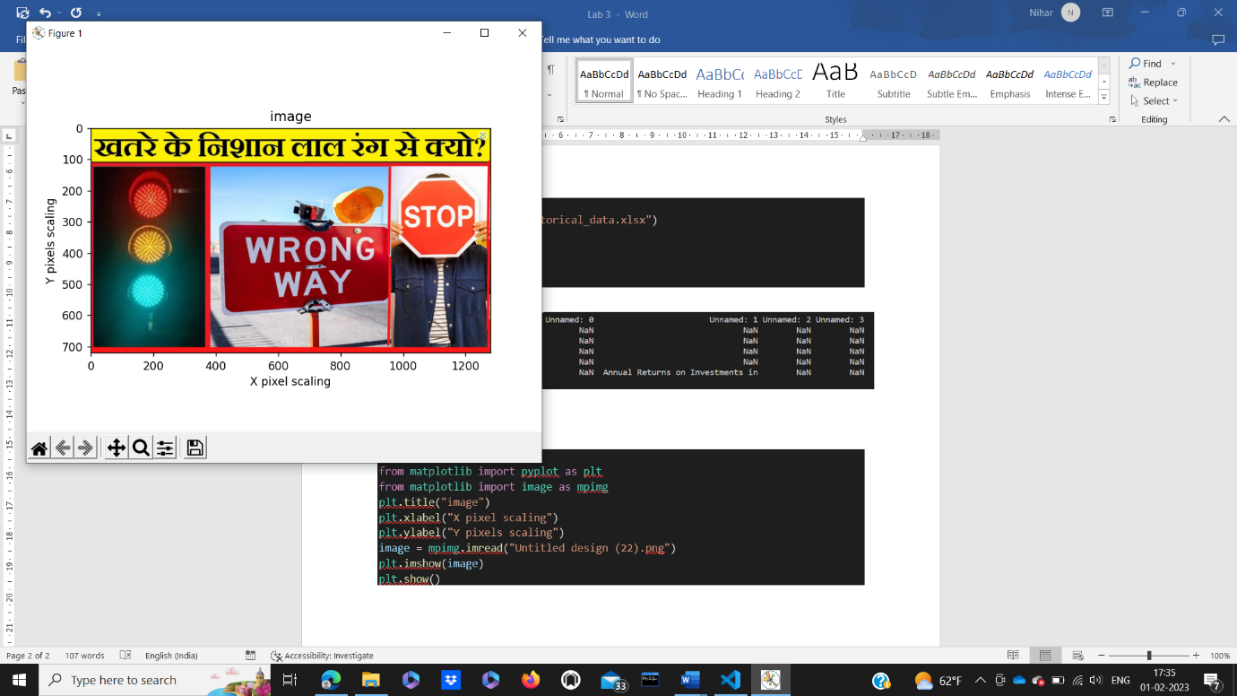

Code:-

#.html

from bs4 import BeautifulSoup

html_file = open("booking.html")

index = html_file.read()

print(index)

#.pda

Output:-

